Line 240 -ukmet

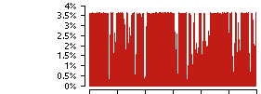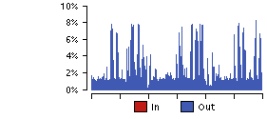  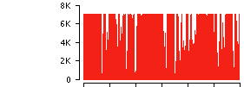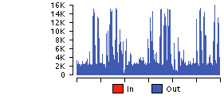  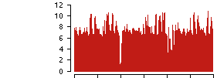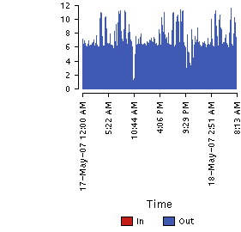 |  | 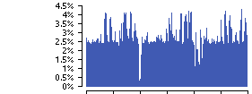  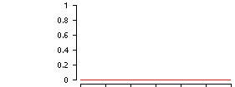  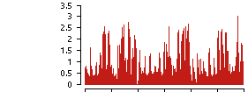  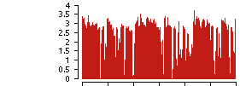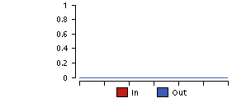  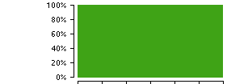  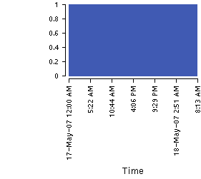
  Bandwidth Utilization
  Bytes (bytes/sec)
  Frames (frames/sec)
  Bandwidth Utilization Total
  FECNs In (frames/sec)
  BECNs In (frames/sec)
  Discard Eligible Frames (frames/sec)
  Availability
  Latency (msec)

Line 227 CN
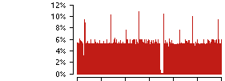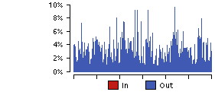  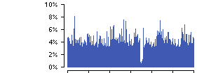  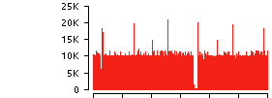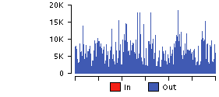  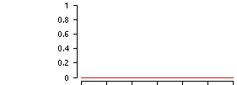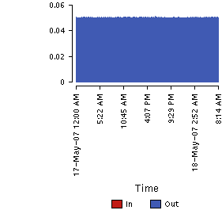 |  | 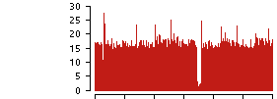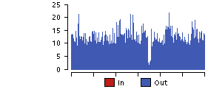  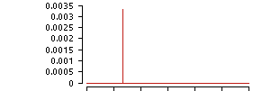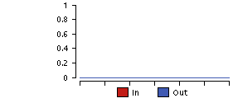  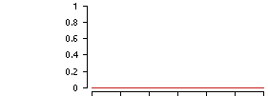  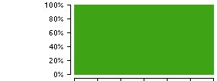  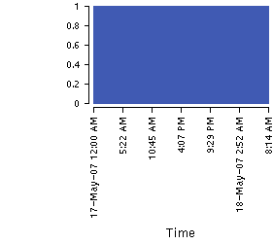
  Bandwidth Utilization
  Bandwidth Utilization Total
  Bytes (bytes/sec)
  NonUnicasts (frames/sec)
  Frames (frames/sec)
  Errors (errors/sec)
  Discards (frames/sec)
  Availability
  Latency (msec)

JMA
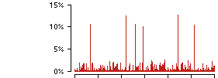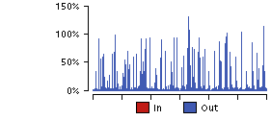  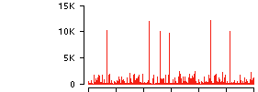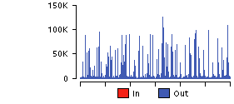  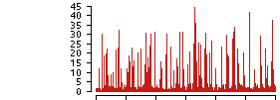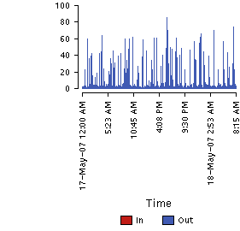 |  | 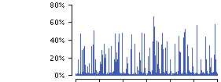  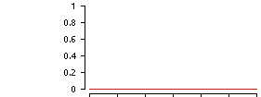  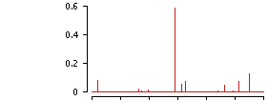  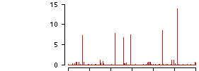  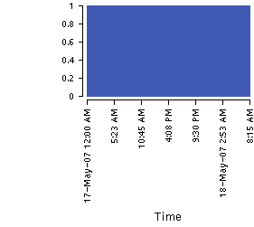
  Bandwidth Utilization
  Bytes (bytes/sec)
  Frames (frames/sec)
  Bandwidth Utilization Total
  FECNs In (frames/sec)
  BECNs In (frames/sec)
  Discard Eligible Frames (frames/sec)
  Availability
  Latency (msec)

Australia
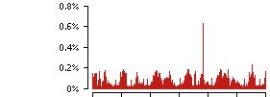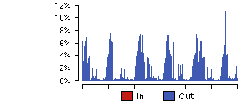  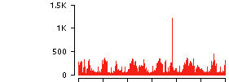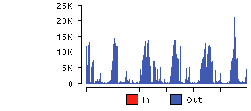  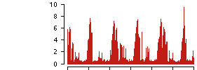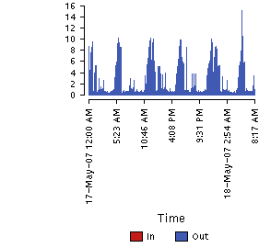 |  | 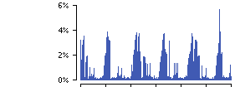  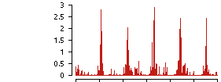  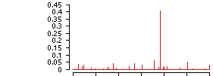  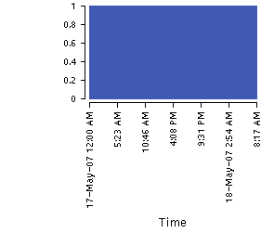
  Bandwidth Utilization
  Bytes (bytes/sec)
  Frames (frames/sec)
  Bandwidth Utilization Total
  FECNs In (frames/sec)
  BECNs In (frames/sec)
  Discard Eligible Frames (frames/sec)
  Availability
  Latency (msec)

THRUPUT CIRCUIT ANALYSIS Fri May 18 12:18:21 2007
171200 - 181200

Line(s): 240,241,242
Baud:64000 Bits:08

Time MxDel(s) SlowLine AvDel(s) Bltns Total Bits
Interval Tx Int Tot Tx Int Tot Tx Int Tot Xmit Chars PerSec

1200 - 1215 68.00 7.00 96.00 240 240 240 13.56 0.83 17.23 947 1110433 9870.52
1215 - 1230 21.00 7.00 65.00 240 240 240 11.69 0.59 14.96 627 557458 4955.18
1230 - 1245 27.00 40.00 81.00 240 240 240 11.09 1.22 14.86 597 518282 4606.95
1245 - 1300 5271.00 54.00 5277.00 241 240 241 1086.13 5.29 1093.99 454 1394028 12391.36
1300 - 1315 5076.00 53.00 5131.00 241 241 241 1615.26 6.07 1623.62 947 3747945 33315.07
1315 - 1330 5219.00 15.00 5220.00 241 241 241 2007.34 1.08 2010.70 650 1705333 15158.52
1330 - 1345 4977.00 47.00 4981.00 241 240 241 2450.99 1.20 2454.60 1163 5087206 45219.61
1345 - 1400 4723.00 50.00 4734.00 241 240 241 2679.77 2.83 2684.93 852 3312657 29445.84
1400 - 1415 3092.00 57.00 3097.00 241 240 241 987.10 3.34 992.41 1094 3240975 28808.67
1415 - 1430 1153.00 43.00 1160.00 241 241 241 515.76 1.97 519.60 584 2734116 24303.25
1430 - 1445 44.00 28.00 113.00 240 240 240 9.77 1.91 14.00 423 474290 4215.91
1445 - 1500 29.00 37.00 57.00 241 241 240 12.70 1.90 16.28 426 1206603 10725.36
1500 - 1515 169.00 43.00 170.00 241 241 241 30.75 4.44 37.29 1035 4475680 39783.82
1515 - 1530 433.00 20.00 436.00 241 241 241 113.41 0.86 115.92 655 1615730 14362.04
1530 - 1545 975.00 29.00 979.00 241 240 241 312.88 0.89 316.23 1093 1956624 17392.21
1545 - 1600 1682.00 39.00 1686.00 241 240 241 759.52 2.60 764.92 860 2491987 22151.00
1600 - 1615 2478.00 56.00 2485.00 241 240 241 1017.59 1.73 1022.77 958 3373772 29989.08
1615 - 1630 3202.00 27.00 3206.00 241 240 241 1739.92 1.52 1744.33 637 1657100 14729.78
1630 - 1645 4092.00 19.00 4097.00 241 240 241 2020.00 1.18 2024.66 525 1553503 13808.92
1645 - 1700 4977.00 35.00 4979.00 241 240 241 3308.42 1.93 3313.38 655 1820656 16183.61
1700 - 1715 5878.00 18.00 5885.00 241 240 241 1978.62 1.10 1982.28 725 1699685 15108.31
1715 - 1730 6769.00 14.00 6774.00 241 240 241 3027.79 0.83 3030.92 546 1642731 14602.05
1730 - 1745 7654.00 56.00 7668.00 241 240 241 3249.92 1.56 3256.55 799 1906498 16946.65
1745 - 1800 8524.00 39.00 8531.00 241 240 241 3773.50 1.49 3780.48 642 1975606 17560.94
1800 - 1815 9414.00 33.00 9430.00 241 240 241 2399.15 0.85 2405.23 963 2290658 20361.40
1815 - 1830 10306.00 6.00 10308.00 241 240 241 2748.92 0.82 2755.67 939 2342239 20819.90
1830 - 1845 11187.00 44.00 11211.00 241 240 241 3996.66 1.05 4003.84 993 2166967 19261.93
1845 - 1900 12004.00 18.00 12005.00 241 240 241 4931.70 0.95 4943.07 767 2250743 20006.60
1900 - 1915 12882.00 20.00 12888.00 241 240 241 5140.93 0.78 5143.96 1000 1928122 17138.86
1915 - 1930 13772.00 14.00 13787.00 241 240 241 6574.92 0.95 6581.21 583 1731927 15394.91
1930 - 1945 14540.00 31.00 14549.00 241 241 241 7601.19 1.13 7607.04 752 1669345 14838.62
1945 - 2000 15340.00 40.00 15371.00 241 240 241 12278.99 9.22 12295.08 1182 3921092 34854.15
2000 - 2015 16155.00 57.00 16197.00 241 240 241 8426.62 10.97 8444.92 962 2815586 25027.43
2015 - 2030 16891.00 32.00 16910.00 241 240 241 11962.75 1.17 11969.40 1144 3475559 30893.86
2030 - 2045 17420.00 51.00 17454.00 241 241 241 14296.44 7.66 14310.09 1960 8241193 73255.05
2045 - 2100 14679.00 47.00 14685.00 241 240 241 10372.92 2.17 10376.75 1475 7923289 70429.24
2100 - 2115 11019.00 30.00 11025.00 241 241 241 4976.98 1.18 4980.11 1129 5355553 47604.92
2115 - 2130 11172.00 26.00 11172.00 241 240 241 5233.58 1.49 5237.07 706 2849653 25330.25
2130 - 2145 10583.00 50.00 10589.00 241 240 241 5303.96 2.16 5308.22 496 2040018 18133.49
2145 - 2200 11209.00 78.00 11213.00 241 240 241 3258.36 6.71 3266.80 442 3314428 29461.58
2200 - 2215 12132.00 46.00 12135.00 241 240 241 2508.88 4.09 2515.25 626 1729698 15375.09
2215 - 2230 12350.00 16.00 12354.00 241 240 241 4441.81 1.13 4445.37 519 1813238 16117.67
2230 - 2245 12362.00 25.00 12368.00 241 241 241 8219.05 1.69 8223.78 776 4194337 37283.00
2245 - 2300 10773.00 44.00 10777.00 241 241 241 6820.66 4.58 6827.69 2500 11977239 106464.35
2300 - 2315 5769.00 49.00 5782.00 241 241 241 3310.14 3.31 3317.92 1247 3755203 33379.58
2315 - 2330 6649.00 19.00 6651.00 241 240 241 3332.17 0.83 3342.92 666 1808500 16075.56
2330 - 2345 7427.00 15.00 7454.00 241 241 241 5643.49 0.86 5654.13 1835 7184916 63865.92
2345 - 0000 8090.00 34.00 8125.00 241 240 241 6673.14 0.84 6685.88 2384 10245540 91071.47
0000 - 0015 8850.00 7.00 8854.00 241 241 241 3705.12 0.76 3711.79 1663 4730211 42046.32
0015 - 0030 9423.00 65.00 9498.00 241 241 241 6772.50 10.89 6791.04 2006 7893572 70165.08
0030 - 0045 9730.00 79.00 9821.00 241 241 241 5883.77 13.11 5901.62 2203 8725481 77559.83
0045 - 0100 8357.00 47.00 8365.00 241 241 241 4072.33 1.97 4076.24 1488 9452029 84018.04
0100 - 0115 3403.00 37.00 3411.00 241 241 241 1444.04 1.06 1447.08 1428 5000067 44445.04
0115 - 0130 1723.00 25.00 1726.00 241 241 241 514.71 1.60 518.60 698 1275275 11335.78
0130 - 0145 21.00 49.00 73.00 240 241 240 9.82 2.17 14.12 451 511727 4548.68
0145 - 0200 372.00 26.00 388.00 241 240 241 84.31 4.57 91.67 627 3381385 30056.76
0200 - 0215 28.00 49.00 116.00 240 240 240 9.58 7.06 18.92 503 556699 4948.44
0215 - 0230 27.00 24.00 85.00 241 240 240 9.70 1.90 13.79 410 498064 4427.24
0230 - 0245 279.00 52.00 283.00 241 240 241 64.18 5.66 72.59 604 2776715 24681.91
0245 - 0300 358.00 29.00 364.00 241 240 241 66.57 1.42 69.93 682 3968246 35273.30
0300 - 0315 60.00 67.00 99.00 240 241 240 12.93 4.16 19.25 697 1927867 17136.60
0315 - 0330 495.00 17.00 495.00 241 241 241 90.62 0.79 93.05 677 1893085 16827.42
0330 - 0345 1132.00 35.00 1139.00 241 240 241 464.45 1.12 467.65 1013 2096154 18632.48
0345 - 0400 2009.00 37.00 2015.00 241 240 241 837.81 1.86 842.32 551 2451749 21793.32
0400 - 0415 2710.00 9.00 2711.00 241 240 241 668.13 0.93 671.50 647 2454661 21819.21
0415 - 0430 3597.00 53.00 3603.00 241 240 241 1825.86 1.51 1829.97 630 1763310 15673.87
0430 - 0445 4397.00 57.00 4405.00 241 240 241 2538.72 1.68 2543.61 583 1469907 13065.84
0445 - 0500 5097.00 12.00 5103.00 241 240 241 3296.69 1.06 3300.97 607 1514652 13463.57
0500 - 0515 5981.00 14.00 5988.00 241 241 241 2710.97 0.92 2716.47 895 1997905 17759.16
0515 - 0530 6854.00 14.00 6856.00 241 241 241 3669.82 0.99 3674.63 662 1960810 17429.42
0530 - 0545 7749.00 14.00 7757.00 241 240 241 2802.13 0.94 2806.78 685 1728900 15368.00
0545 - 0600 8630.00 58.00 8641.00 241 240 241 4051.75 1.39 4056.70 505 1475866 13118.81
0600 - 0615 9518.00 36.00 9525.00 241 240 241 2840.81 1.32 2846.63 1012 2432272 21620.20
0615 - 0630 10407.00 7.00 10424.00 241 240 241 3689.89 0.78 3696.61 791 1822263 16197.89
0630 - 0645 11298.00 7.00 11302.00 241 240 241 4751.73 0.84 4759.62 732 1854272 16482.42
0645 - 0700 12057.00 47.00 12094.00 241 240 241 9770.42 5.41 9782.90 1868 7262811 64558.32
0700 - 0715 12842.00 25.00 12847.00 241 241 241 6269.79 4.84 6280.04 979 2708752 24077.80
0715 - 0730 13753.00 5.00 13757.00 241 240 241 5688.77 1.00 5691.30 438 1507428 13399.36
0730 - 0745 14396.00 25.00 14416.00 241 240 241 12655.24 1.97 12664.26 2695 11352125 100907.78
0745 - 0800 14430.00 50.00 14456.00 241 241 241 12576.94 1.76 12583.03 2211 8606436 76501.65
0800 - 0815 12929.00 54.00 12951.00 241 241 241 7810.38 1.17 7813.72 1060 1867599 16600.88
0815 - 0830 12234.00 44.00 12243.00 241 240 241 8723.57 1.88 8727.46 949 5492862 48825.44
0830 - 0845 10274.00 40.00 10281.00 241 241 241 6820.95 1.38 6824.02 1398 7380303 65602.69
0845 - 0900 5834.00 62.00 5837.00 241 241 241 2202.65 2.76 2207.50 1138 6220624 55294.44
0900 - 0915 339.00 14.00 342.00 241 241 241 46.48 1.13 49.45 677 2568218 22828.60
0915 - 0930 346.00 56.00 347.00 241 240 241 54.95 2.09 59.25 514 1540430 13692.71
0930 - 0945 834.00 58.00 839.00 241 241 241 271.97 1.48 278.02 634 1966575 17480.67
0945 - 1000 1711.00 23.00 1739.00 241 241 241 608.91 6.93 618.58 534 2729905 24265.82
1000 - 1015 2487.00 42.00 2496.00 241 240 241 750.95 2.71 757.15 852 1871980 16639.82
1015 - 1030 3237.00 53.00 3242.00 241 240 241 1589.03 1.24 1592.52 564 1599311 14216.10
1030 - 1045 4125.00 31.00 4129.00 241 240 241 2505.05 1.78 2509.63 1017 3775747 33562.20
1045 - 1100 4963.00 39.00 4977.00 241 240 241 4049.13 1.96 4056.50 2394 10588528 94120.25
1100 - 1115 5669.00 29.00 5675.00 241 240 241 3223.76 1.17 3233.41 1366 4604704 40930.70
1115 - 1130 6564.00 24.00 6579.00 241 240 241 3118.03 0.76 3124.36 712 2139508 19017.85
1130 - 1145 6946.00 38.00 6963.00 241 240 241 5462.72 1.55 5472.28 2039 8304032 73813.62
1145 - 1200 7312.00 58.00 7316.00 241 241 241 5718.07 2.87 5725.32 1667 7059500 62751.11

Total characters transmitted : 327044463
Total bulletins transmitted : 93096
Average Tx Delay : 3541.60
Average Internal Delay : 2.45
Average Total Delay : 3547.83

[tgp19] - /home/starostd
->

